QUESTIONS:
- Find the bugs in the following snippet.
int linearSearch(int arr[], int n, int key) {
for(int i = 0; i <= n; i++) {
if(arr[i] == key)
return i;
}
return -1;
}

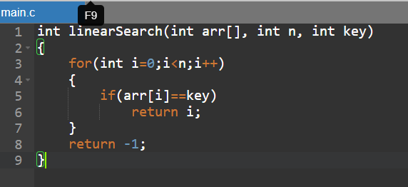
- Identify the error in the following snippet.
int found = 0;
for(int i = 0; i < n; i++) {
if(arr[i] == key)
found = 1;
}
if(found = 1)
return 1;
else
return -1;
}

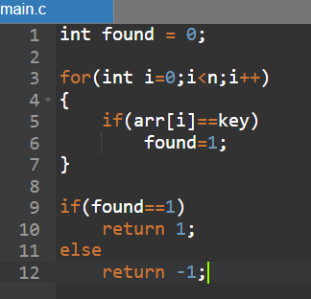
- Find the bugs in the given snippet.
int binarySearch(int arr[], int n, int key) {
int low = 0, high = n - 1;
while(low <= high) {
int mid = (high - low )/2;
if(arr[mid] == key)
return mid;
else if(arr[mid] < key)
low = mid + 1;
else
high = mid - 1;
}
return -1;
}

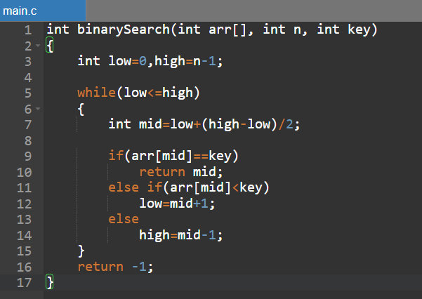
- Identify the error in the following snippet.
int binarySearch(int arr[], int n, int key) {
int low = 0, high = n - 1;
while(low < high) {
int mid = (low + high) / 2;
if(arr[mid] == key)
return mid;
else if(arr[mid] < key)
low = mid;
else
high = mid;
}
return -1;
}
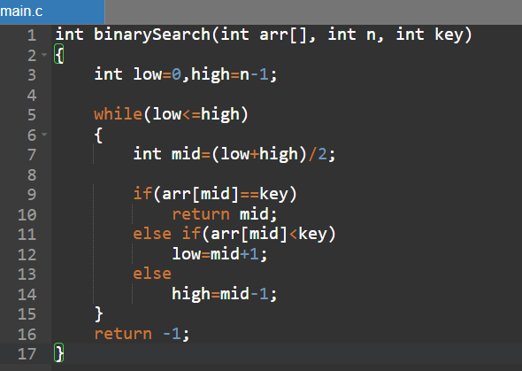
- Where is the error? Identify it.
int arr[] = {10, 5, 20, 15, 30};
int result = binarySearch(arr, 5, 15);
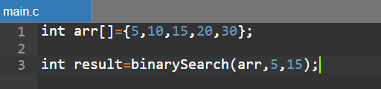

- Identify the error and give me the correct answers.
#define MAX 5
int stack[MAX];
int top = -1;
void push(int x) {
if(top == MAX) {
printf("Overflow");
return;
}
stack[++top] = x;
}

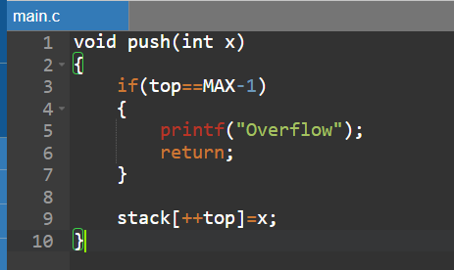
- Find the error in the stack deletion operation. Justify it.
int pop() {
if(top == 0) {
printf("Underflow");
return -1;
}
return stack[top--];
}

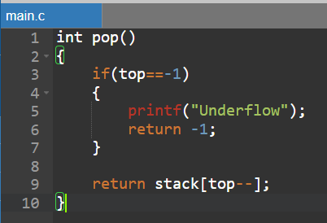

- What is the issue in the following snippet?
void push(int x) {
stack[top++] = x;
}

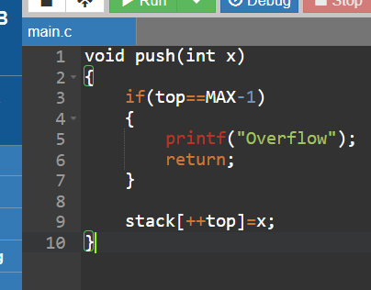
- Check the snippet and identify the logical error.
int stack[5];
int top;
void init() {
top = 0;
}

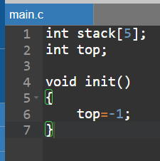
- What is the issue in the following snippet?
#define MAX 5
int queue[MAX];
int front = 0, rear = 0;
void enqueue(int x) {
if(rear == MAX) {
printf("Overflow");
return;
}
queue[rear++] = x;
}

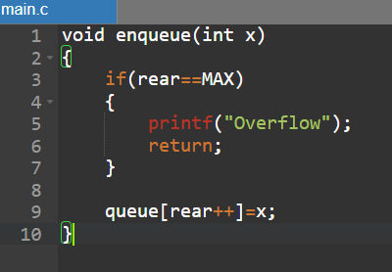
- What is the issue in the following snippet? Identify it.
int dequeue() {
if(front == rear) {
printf("Underflow");
return -1;
}
return queue[front++];
}
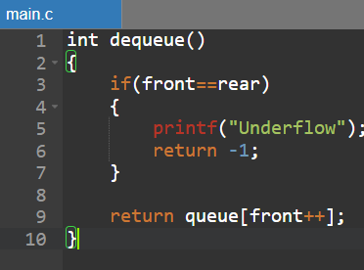
- Identify the issue in the following snippet.
void enqueue(int x) {
queue[rear++] = x;
}
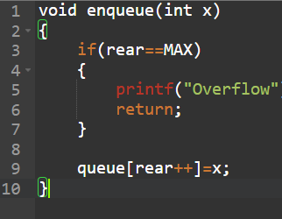

- Find the issue in the following code snippet.
#define MAX 5
int queue[MAX];
int front = -1, rear = -1;
void enqueue(int x) {
if(rear == MAX - 1) {
printf("Overflow");
return;
}
if(front == -1)
front = 0;
rear = (rear + 1) % MAX;
queue[rear] = x;
}

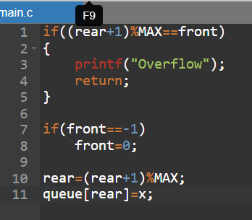
- Identify the logical error in the following snippet.
int dequeue() {
if(front == -1) {
printf("Underflow");
return -1;
}
int val = queue[front];
front = (front + 1) % MAX;
return val;
}

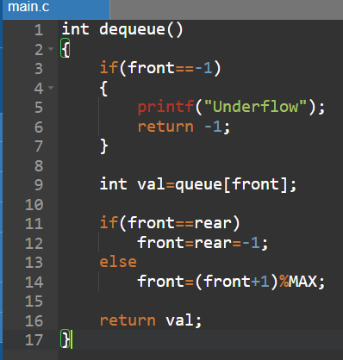
- What is the issue in the following code?
int dequeue() {
int val = queue[front];
if(front == rear)
front = rear = -1;
else
front = front + 1;
return val;
}
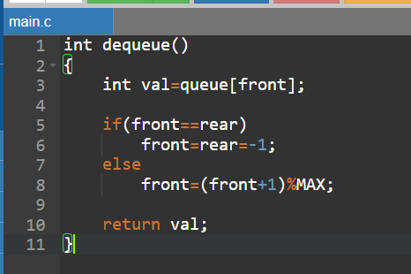
- Identify the errors in the following snippet.
if(ch == ')') {
while(stack[top] != ')') {
postfix[j++] = pop();
}
pop();
}
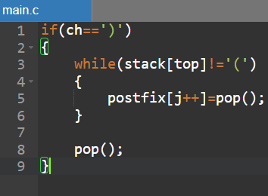
- For infix to post fix conversion, identify the error.
int precedence(char ch) {
if(ch == '+' || ch == '-')
return 2;
else if(ch == '*' || ch == '/')
return 1;
return 0;
}
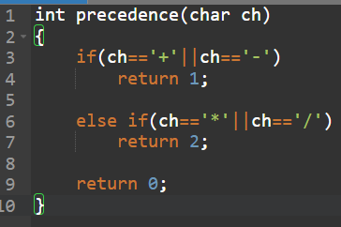
- In postfix expression evaluation, identify the error.
int a = pop();
int b = pop();
int result = a - b;
push(result);

- 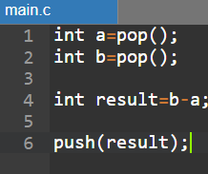
In balancing Bracket, you identify the error.
if((ch == ']' && stack[top] == '[') ||
(ch == '}' && stack[top] == '{')) {
pop();
} else {
return 0;
}

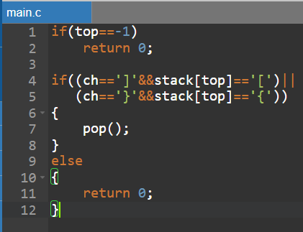
- Identify the errors in the following code snippet
struct node *temp = head;
while (temp != NULL) {
temp = temp->next;
}
temp->next = newNode;

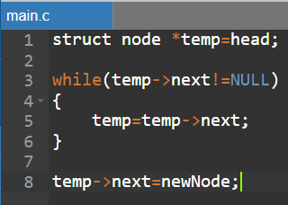
- What is the error in the given pseudocode?
PUSH(stack, x):
if top == MAX:
print("Overflow")
else:
top = top + 1
stack[top] = x
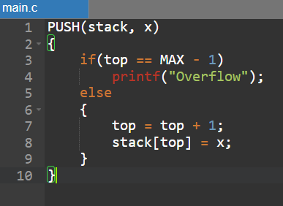
- Even when there is space, overflow occurs. Why?
ENQUEUE(Q, x):
if rear == MAX - 1:
print("Overflow")
else:
rear = rear + 1
Q[rear] = x
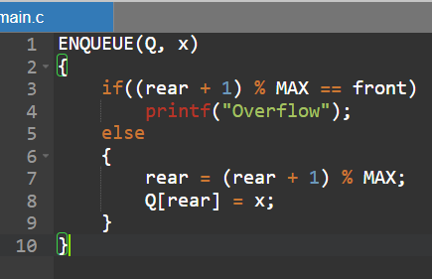
- What is the issue?
temp = head
while temp.next != NULL:
print(temp.data)
temp = temp.next
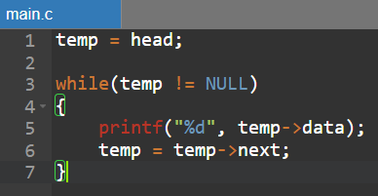
- What is the potential issue in mid = (low + high) / 2?
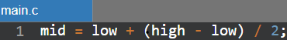
- What is the issue in the below pseudocode?
for i = 0 to n:
if arr[i] == key:
return i
return -1
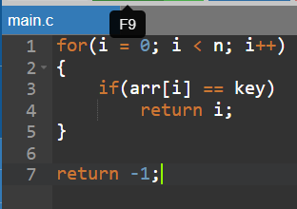
- Point out the error.
POP(stack):
if top == 0:
print("Underflow")
else:
return stack[top--]
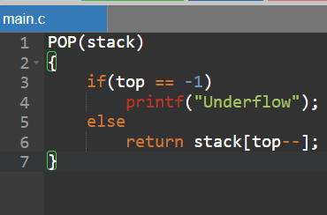
- Applying binary search on unsorted data results in:
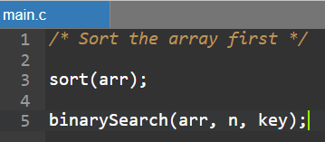
- Which condition correctly detects a full circular queue?
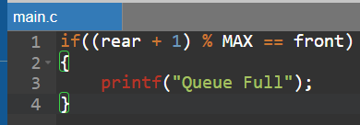
- What is the issue in the below code?
delete(node):
node = node.next
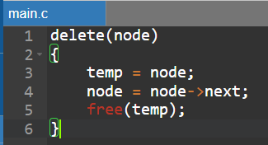
- Identify the truth in time complexity analysis.
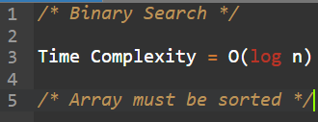
- Identify the errors in the following code
while current != NULL:
current.next = prev
prev = current
current = current.next
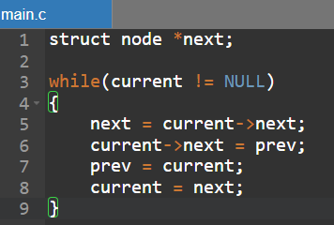
- What is the error in the below code?
new.next = head
head = new
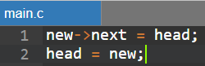
- What is missing in the below pseudocode?
DEQUEUE(Q):
if front == -1:
print("Underflow")
else:
return Q[front++]
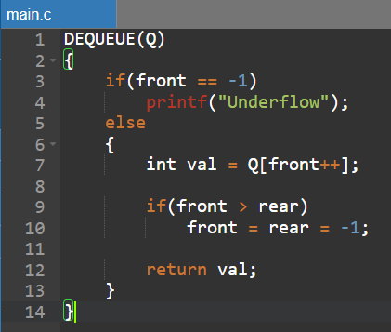
- Point out the error?
PEEK(stack):
return stack[top+1]
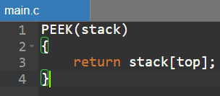
- Identify the error in the code while low < high:
A. Should be low <= high
- What is the issue in the following C code.
struct node {
int data;
struct node *next;
};

void insert(struct node *head, int val){
struct node *temp = (struct node*)malloc(sizeof(struct node));
temp->data = val;
temp->next = head;
head = temp;
}
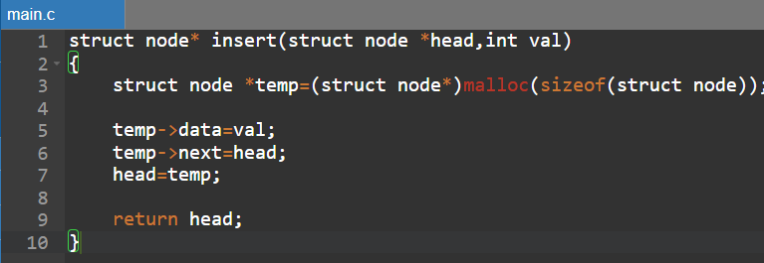
- Identify the error in the doubly linked list.
newNode->next = head;
head->prev = newNode;
head = newNode;
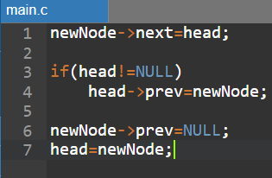
- What is the logical error in the following snippet.
if(rear == MAX-1){
printf("Full");
}
queue[++rear] = x;
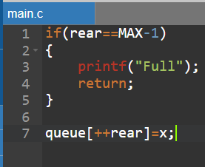
- In a linear search algorithm, what are the bugs?

for(i=0; i<n-1; i++){
if(arr[i] == key)
return i;
}

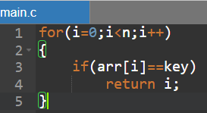
- What is the error in the binary search code snippet.
while(low < high){
mid = (low + high)/2;
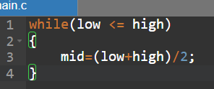
- Which of the following describes the primary goal of searching?
// Searching is used to locate a specific element in a list.
- How does binary search reduce the search space in each step?
// Binary Search eliminates half of the remaining elements in every step.
- Identify the errors.
while(priority(stack[top]) >= priority(symbol)){
printf("%c", pop());
}
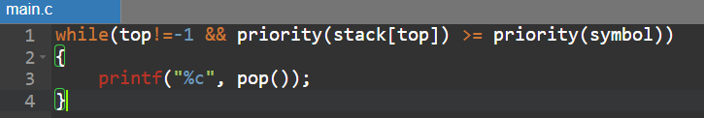
- In the linear data structure of the circular queue, what are the error.
if((rear + 1) % MAX == front){
printf("Full");
}
rear = (rear + 1) % MAX;
queue[rear] = x;

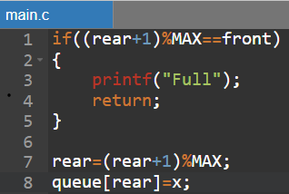
- What is the issue in the following coing snippet.
struct node* insert(struct node *head, int val){
struct node *temp = (struct node*)malloc(sizeof(struct node));
temp->data = val;
temp->next = head;
}
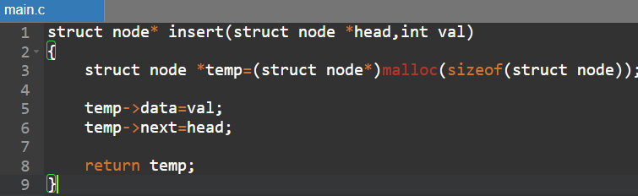
- Find the logic errors in the given snippet.
struct node* insert(struct node *head, int val){
struct node *temp = (struct node*)malloc(sizeof(struct node));
temp->data = val;
temp->next = NULL;
head = temp;
return head;
}
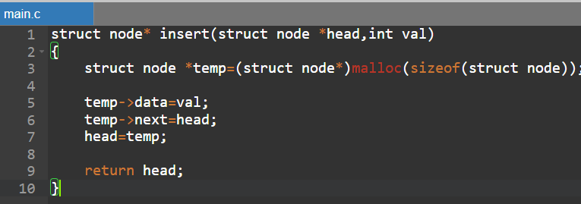
- Identify the logical errors in the given DLL snippet.
struct node* insertEnd(struct node *head, int val){
struct node *temp = (struct node*)malloc(sizeof(struct node));
temp->data = val;
temp->next = NULL;

struct node *ptr = head;
while(ptr->next != NULL){
ptr = ptr->next;
}
ptr->next = temp;
temp->prev = ptr;
}
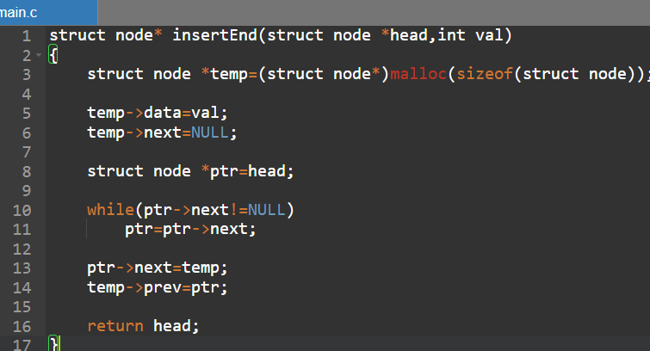
- Find the logical error in the snippet given below.
struct node* insertEnd(struct node *head, int val){
struct node *temp = (struct node*)malloc(sizeof(struct node));
temp->data = val;
temp->next = NULL;

struct node *ptr = head;
while(ptr->next != NULL){
ptr = ptr->next;
}
ptr->next = temp;
ptr->prev = temp;
return head;
}
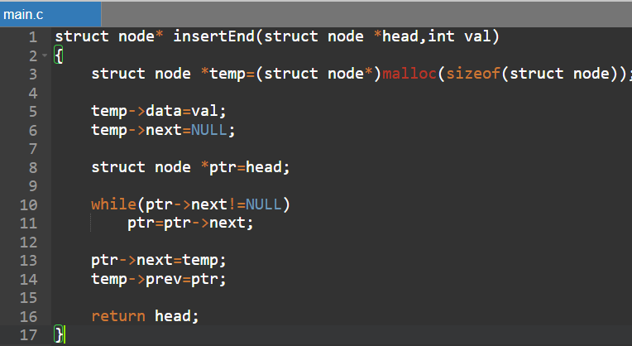
- What is the worst-case time complexity of a binary search?
C) O(log n)

- Identify the issue in the following snippet for Circular Queue in Traffic Signal.
rear = (rear + 1) % MAX;
queue[rear] = vehicle;
if(rear == front){
printf("Queue Full");
}
- 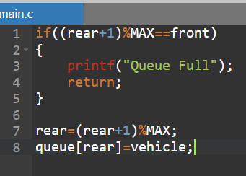

Code of Conduct:

I ____________________ (Name / Reg No) certify that this submission is my original work and that I have adhered to the guidelines specified for this assessment.
I understand that any violation of academic integrity rules will result in disciplinary action.

Signature of the student:

RUBRICS FOR CALCULATION:
Numerical Problems
Criteria | Weightage | Level 4 (Exemplary) | Level 3 (Proficient) | Level 2 (Developing) | Level 1 (Beginning)
Problem Understanding | 20% | Clearly interprets problem, identifies all parameters and requirements accurately | Understands problem with minor gaps | Partial understanding; misses key elements | Misinterprets or unable to understand problem
Method Selection | 20% | Selects most appropriate method/formula with strong justification | Selects correct method with minor errors | Inappropriate or partially correct method | Unable to select method
Solution Process | 25% | Logical, systematic steps with correct approach throughout | Mostly correct steps with minor mistakes | Disorganized steps; multiple errors | No clear process
Accuracy of Calculation | 20% | All calculations accurate; correct final answer | Minor calculation errors | Frequent errors; incorrect final answer | No valid calculations
Interpretation of Results | 15% | Clearly interprets results with units and engineering relevance | Basic interpretation with minor omissions | Limited or unclear interpretation | No interpretation

